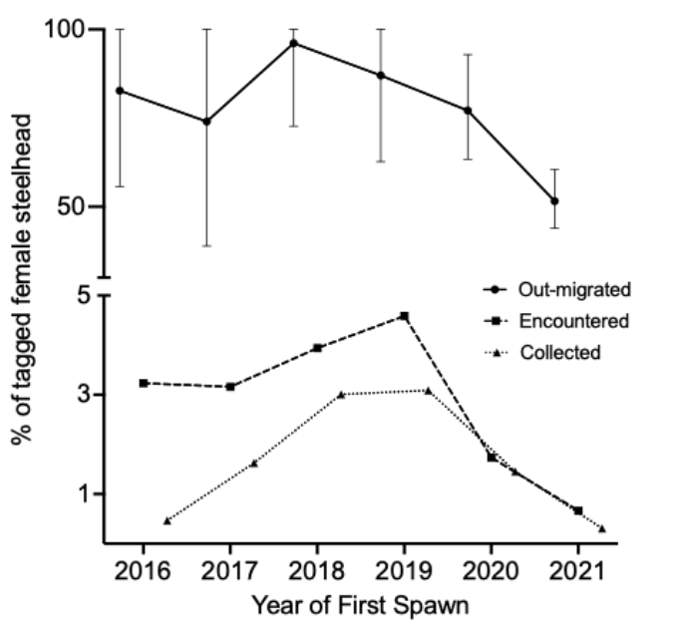
Figure 1. Downstream migration, encounter, and collection rates of natural-origin female steelhead at Lower Granite Dam (LGD). The solid line indicates an estimate of percentage of fish that migrated downstream (out-migrated). Error bars indicate 95% confidence intervals. The dashed line indicates fish that were encountered (N = 300), and the dotted line indicates fish that were collected for reconditioning (N = 150).

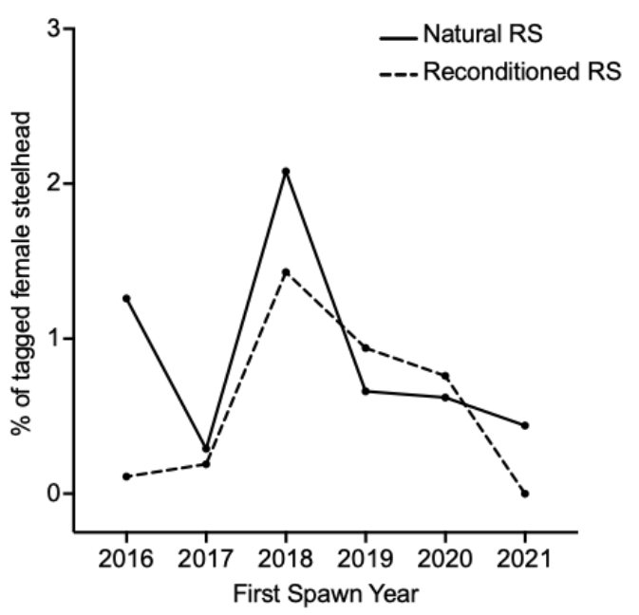
Figure 2. Rate of detection of natural-origin female steelhead at Lower Granite Dam (LGR) fish ladder PIT arrays during a second spawning migration as a percentage of those that were PIT-tagged at the LGR adult fish trap during their first spawning migration. The solid line indicates repeat spawners (RS) not reconditioned by the kelt reconditioning program (KRP) (Natural RS, N = 96) and the dashed line indicates RS released from the KRP (Reconditioned RS, N = 48).

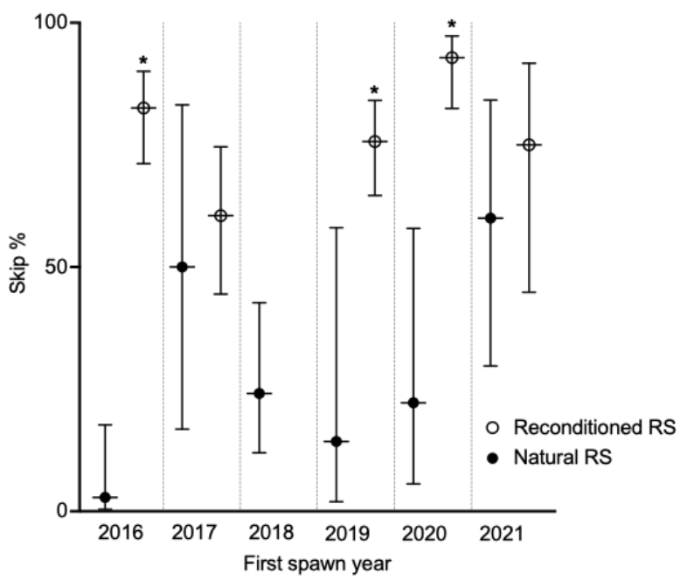

Figure 3. The rate of skip spawning in natural-origin female repeat spawners (RS) that were tagged at Lower Granite Dam (LGR) adult fish trap during their first upstream spawning migration and then detected migrating upstream through LGR in a subsequent year. Those reconditioned by the Kelt Reconditioning Program and then detected migrating through LGR after release are shown above as open circles (N = 243 total, N = 51 consecutive, 192 skip, after the exclusion of fish that first spawned in 2018). Natural RS are shown above (solid circles, N = 96 total, N = 76 consecutive, 20 skip), though those from first spawn year 2018 were not included in the analysis (N = 29 total, 22 consecutive, 7 skip). The probability of skip spawning was significantly greater in Reconditioned RS in first spawn years 2016, 2019, and 2020 (GLM; P = 1.95 x 10⁻⁶, 0.01, and 6.40 x 10⁻⁵, respectively, significance indicated by asterisks).

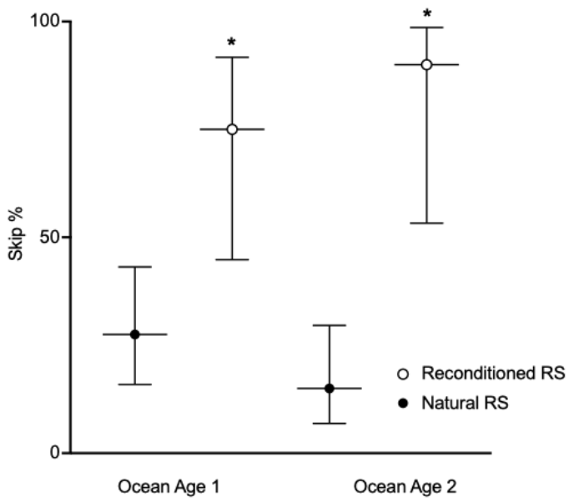
Figure 4. The rate of skip spawning in natural-origin female repeat spawners (RS, N = 102) that were tagged at Lower Granite Dam (LGR) adult fish trap during their first upstream spawning migration and then detected migrating above LGR in a subsequent year (Natural RS, solid circles, N = 80 total; Ocean Age 1, N = 40, Ocean Age 2, N = 40) or that were reconditioned by the Kelt Reconditioning Program, and then detected migrating through LGR after release (Reconditioned RS, open circles, N = 22; Ocean Age 1, N = 12, Ocean Age 2, N = 10). The probability of skip spawning was significantly greater (p = 0.006 in Ocean Age 1, p = 0.0006 in Ocean Age 2). Reconditioned fish from first spawn year 2018 were excluded from the analysis.

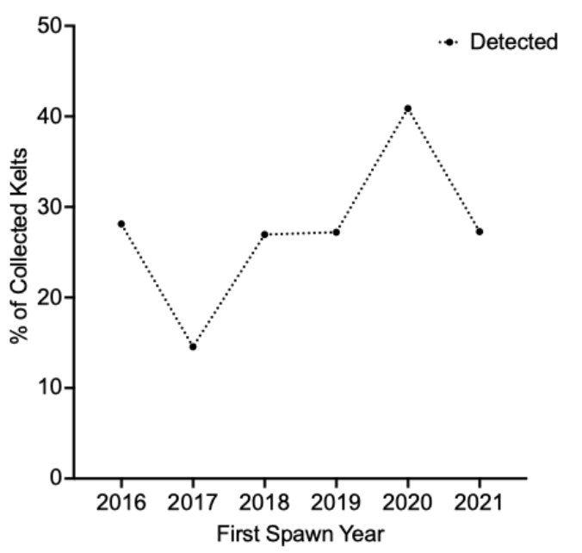
Figure 5. Rate of detection of natural-origin female steelhead at Lower Granite Dam fish ladder PIT arrays during a second (repeat) spawning migration as a percent of those that were collected from Lower Granite Dam Juvenile Bypass during their post-spawning migration.

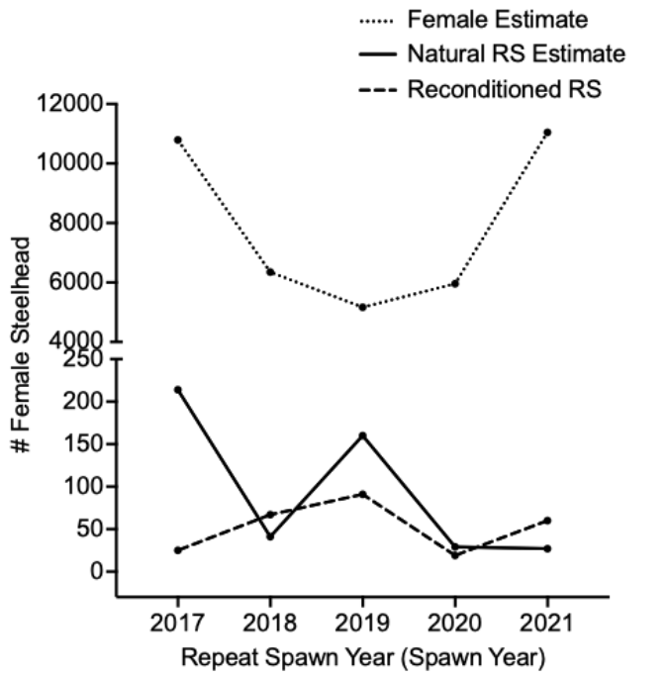

Figure 6. Estimate of the total number of natural-origin female steelhead migrating upstream each year (2017-2021, dotted line), estimate of the number of Natural repeat spawners (RS) migrating upstream each year (solid line), and number of Reconditioned RS detected migrating upstream through Lower Granite Dam (LGR) after release (dashed line). The x-axis indicates spawn year (for the estimate of total female run) or repeat spawn year for repeat spawners. For the estimate of the total number of natural-origin female steelhead migrating upstream each year, the total run estimate for each year was multiplied by the percent of females that were tagged at LGR adult fish trap each year. For the estimate of the number of Natural RS, the number of Reconditioned RS detected migrating upstream through LGD was subtracted from the total estimate of RS for each year. For all RS, the number for each year includes females that first spawned one or two years prior. In spawn year 2020, only fish that spawned one year prior are represented for Reconditioned RS, as all but one skip collected in spring 2018 was lost due to a mechanical failure.

